CHUNKING IN UID
NAME: MAGESHWARAN M
ROLL NO:240701299

CHUNKING IN AUTOMOBILE
1. Definition of Chunking
Chunking is a method of presenting information by splitting concepts into small pieces of information that are easily digestible. rather than long paragraphs, content is grouped into meaningful sections using Headings, Subheadings, and Bullet Points
1. Why Chunking Matters for Car Websites
Car websites are data-heavy. Users are looking at specs, pricing, safety ratings, and features simultaneously. Without chunking, this information becomes a "Wall of Text," leading to:
- Cognitive Overload: The user gets confused by too many numbers and details.
- High Bounce Rate: Users leave the page because they can't find specific info (like mileage or safety) quickly.
- Decision Paralysis: Users struggle to compare complex models (e.g., Kia Seltos vs. VW Taigun) effectively.

2. Chunking Strategies for My Project
A. The "Feature Cluster" Strategy
Instead of listing 50 features in a random list, group them by User Benefit.
- Performance Chunk:
  - Engine Capacity & Torque
  - Transmission Type (Manual/Automatic/DCT)
  - 0-100 km/h acceleration time
- Comfort Chunk:
  - Touchscreen Size & Infotainment
  - Sunroof Type (Panoramic vs. Single)
  - Ventilated Seats

MAIN INTERFACE WITH THE CARS TYPES
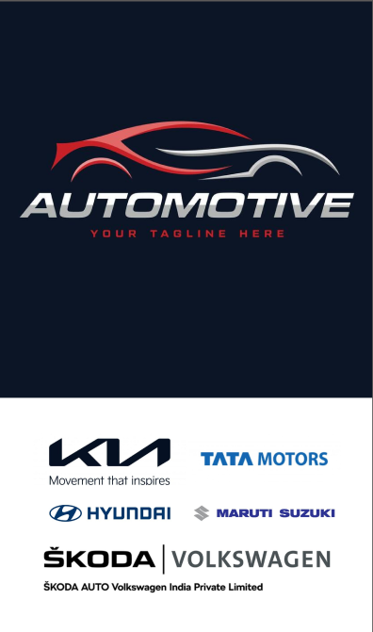

INTERFACE WITH THE KIA CAR TYPES AS A GROUP
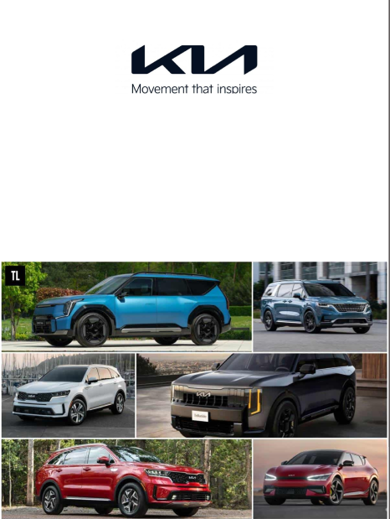

Webpage 1: Kia Motors
Theme: Modern, Tech-Loaded, Youthful
- Subtopic: Brand Identity
  - Slogan: "Movement that Inspires"
  - Focus: Futuristic design and aggressive styling ("Tiger Nose" Grille).
  - Target Audience: Young professionals and tech-savvy buyers.
- Subtopic: Key Features (The "Tech" Chunk)
  - Smart Connectivity: Kia Connect with 60+ connected car features.
  - Cabin Experience: Bose premium sound systems and mood lighting.
  - Convenience: Ventilated seats and built-in air purifiers in mid-range models.
- Subtopic: Top Models
  - Seltos: Mid-size SUV, best-seller, known for premium interiors.
  - Sonet: Compact SUV, feature-rich, ideal for city driving.
  - EV6: Premium electric crossover with super-fast charging.

INTERFACE WITH THE TATA MOTORS CAR TYPES AS A GROUP
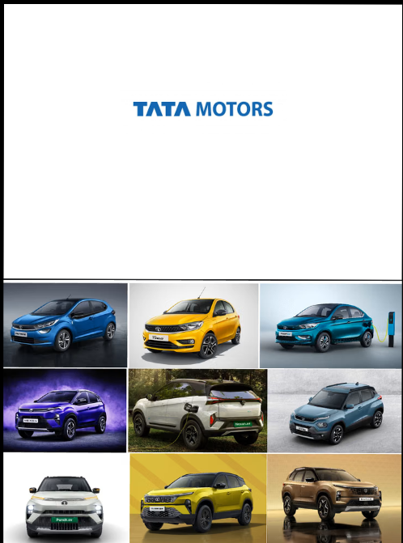

Webpage 2: Tata Motors
Theme: Safe, Rugged, Electric Leader
- Subtopic: Brand Identity
  - Slogan: "Connecting Aspirations"
  - Focus: #DeshKaLoha (Iron of the Nation) – synonymous with strength.
  - Market Position: India’s #1 Electric Vehicle manufacturer.

- Subtopic: Safety & Build (The "Trust" Chunk)
  - Global NCAP Ratings: Pioneer of 5-star safety in India (Nexon, Punch, Safari).
  - Structure: Heavy-gauge steel construction for maximum crash protection.
  - Ride Quality: Suspension specifically tuned for rough Indian roads.
- Subtopic: Top Models
  - Nexon: India's first 5-star safety rated car; available in Petrol, Diesel, EV.
  - Punch: "Micro-SUV" offering high ground clearance on a budget.
  - Safari: Flagship 7-seater SUV with Land Rover-derived architecture.

INTERFACE WITH THE VOLKSWAGEN CAR TYPES AS A GROUP
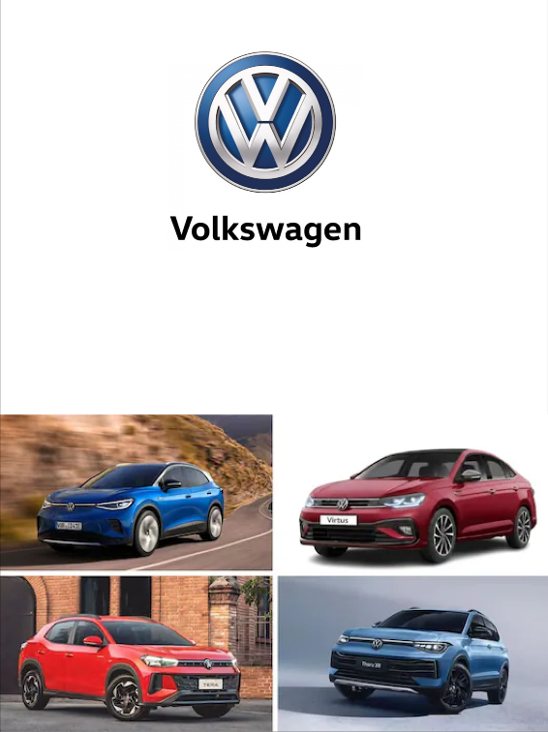

Webpage 3: Volkswagen
Theme: Precision, Performance, Timeless
- Subtopic: Brand Identity
  - Philosophy: German Engineering & "Fun-to-Drive" dynamics.
  - Aesthetics: Clean, understated, and timeless European design.
  - Safety Standard: "Safe like a Volkswagen" (5-Star ratings for Virtus/Taigun).
- Subtopic: Performance Engineering (The "Drive" Chunk)
  - Engine Tech: TSI (Turbo Stratified Injection) engines for high power and efficiency.
  - Transmission: DSG (Direct Shift Gearbox) for lightning-fast gear shifts.
  - Handling: Laser-welded chassis for superior high-speed stability.
- Subtopic: Top Models
  - Virtus: Performance sedan known for its powerful 1.5L GT engine.
  - Taigun: Compact SUV offering a balance of comfort and handling.
  - Tiguan: Premium SUV with superior build quality and luxury features.

Why This "Chunking" Works for my Project
- Scannability: Users can find "Safety" or "Engine" details in seconds without reading a paragraph.
- Comparison: A user can easily look at the "Key Features" chunk on the Kia page and compare it to the "Safety" chunk on the Tata page.
- Mobile Friendly: Bullet points and short headers look much better on mobile screens than long text blocks.

